Experiment-1
write an python program to solve a 8 puzzle problem
Aim
To write and execute a Python program to solve the 8-Puzzle problem using Breadth-First Search (BFS) and find the sequence of moves required to reach the goal state.
Algorithm
- Start with the initial 8-puzzle state.
- Represent the blank space using 0.
- Define the goal state as:
1 2 3 / 4 5 6 / 7 8 0
- Store the initial state in a queue.
- Find the position of the blank space (0).
- Move the blank space up, down, left, or right wherever possible.
- Generate new puzzle states after each valid move.
- Store visited states to avoid repeating states.
- Continue removing states from the queue and generating new states.
- If the goal state is reached, display the sequence of states and total number of moves.
- If the queue becomes empty without reaching the goal, display No solution exists.
Coding
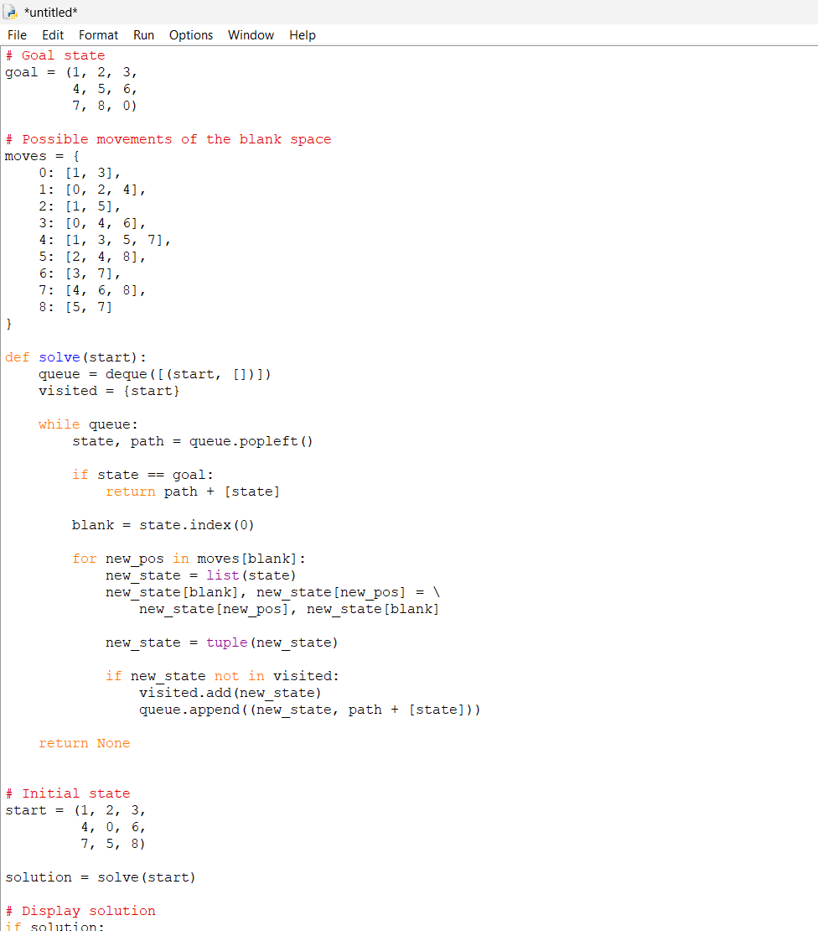
Output
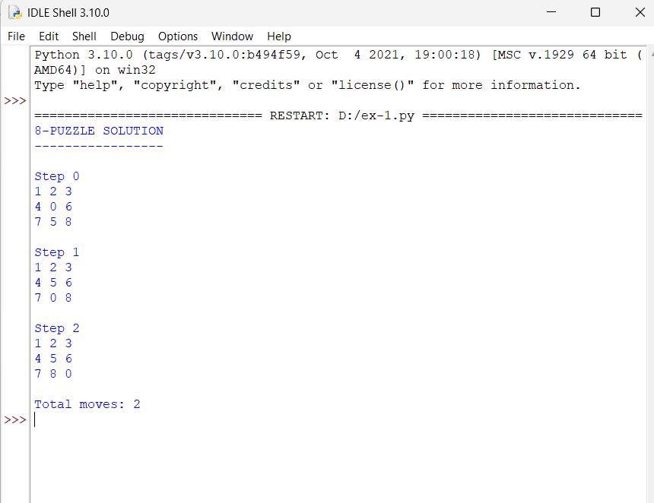

Result
The 8-Puzzle problem was successfully solved using Breadth-First Search (BFS) . The program finds and displays the sequence of moves from the initial state to the goal state.

